**Session report 28/10/2022:**

*LABAUVIE – RAFFAELLI EVA*

*ROB3*

For this session I tried to start to use the servomotor for the wheel direction.

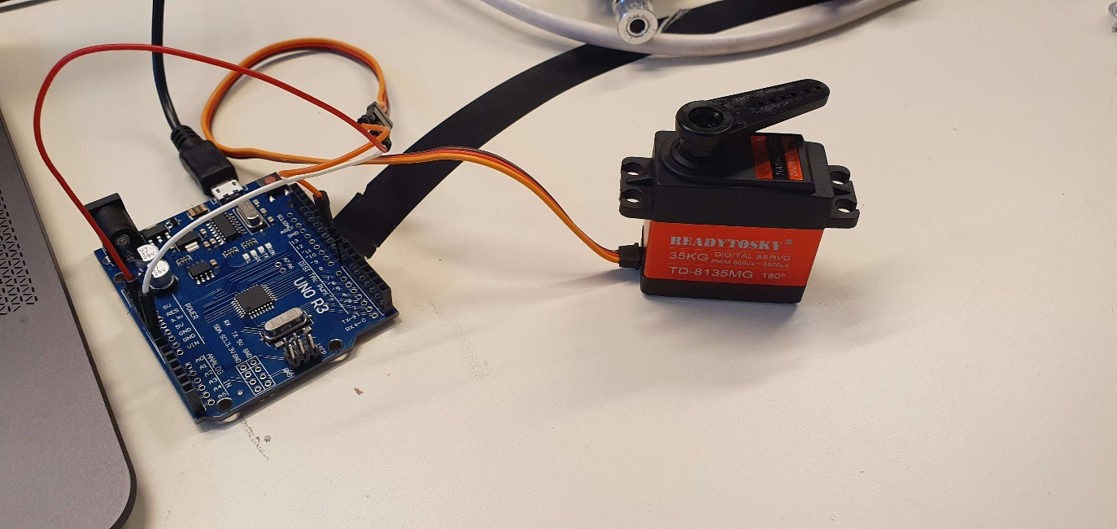

Next, I tried to find the right way to link the wheels and the motor for the direction system.

After discussing about the wheel direction solution, we decided to abandon the servomotor idea, because it is too complicated to make it work combined with 4 drive wheels.

The new idea will be to have a robot with two “compartments”, one assuring the movement with the four wheels, towing the second one that would be the sorting block (collecting and sorting the rubbish).

